**Notice of Public Meeting of a Public Body**

Section 7.6.2, 7.7.4, and 7.9.1

**NOTICE OF CANCELLATION OF PUBLIC MEETING OF THE BOARD OF**

**HARVEST PREPARATORY ACADEMY**

Pursuant to A.R.S. 38-431.02, notice is hereby given to the members of the board of Harvest Preparatory Academy and to the general public that the Harvest Preparatory Academy Board of Directors regularly meeting scheduled to be held on November 12, 2019, at 4:30p.m. at 1748 South Arizona Avenue. Yuma, Arizona will be **CANCELLED** in accordance with school by laws and board policies and procedures.

**Dated this 12th day of November, 2019**

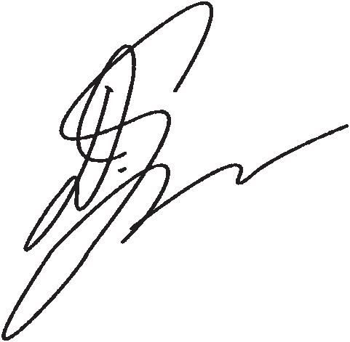Harvest Preparatory Academy

By_________________________________

Debi Ybarra, President